Peer Review by Students
John Paul Kanwit and Samantha Demmerle

Peer review is an activity that exists in a variety of contexts (for example, a peer-reviewed scholarly manuscript or peer review of teaching), but as a pedagogical strategy it implies a situation in which students provide written or verbal feedback for each other on an on-going project. Peer review is a real-life skill that requires students to communicate clearly about project expectations, analyze different styles of language, and assess their own work in relation to others. Peer review is a useful tool in both online and face-to-face classes to foster community and to encourage formative self-assessment (Boettcher and Conrad, 2016; Griffin, 2018). In addition to promoting self-reflection, peer review increases the active learning potential of students (Mulder et al., 2014; Li et al. 2010; Wanner & Palmer, 2018). Instead of passively waiting for instructors to provide the feedback in a course, students learn to respond to their peers’ work in productive and focused ways. In so doing, students learn more about the assignment, about their own strategies for composing written work, and about different ways of approaching a rhetorical task.
Peer review can be frustrating to students who approach the task with low expectations of their peers' feedback. In order to facilitate a productive exchange of feedback, the emphasis should be on the feedback students provide, not just on the feedback they receive. With this emphasis on active reflection, self-assessment, and the writing process--not product--students will develop interpersonal communication skills that will aid their own rhetorical clarity. To this end, instructors should consider when and how they will communicate about peer review with their students. While instructors often devote only single days to peer review, the strategy works best when integrated throughout a course, across multiple projects and drafts. This recursive process will allow instructors to coach students to provide effective feedback to their peers.
Pedagogical Implementation
- Determine how many writing assignments and peer reviews you will assign in your course.
- Specify in your syllabus how much these writing assignments and peer reviews count towards the overall course grade (be sure to count peer review substantially in the course grade if you want students to take the assignment seriously).
- Establish clear guidelines (purpose, task, audience, evaluation criteria) and rubrics for each assignment.
- Write structured feedback forms for students that are based on your rubrics.
- Allow students to practice peer review at least once before they are graded on the feedback that they provide.
- Before the first paper is due, set aside class time to explain strategies for good feedback. This is a chance to explain the rubric in depth, provide model assignments and model feedback, and discuss the value of constructive feedback.
- Have peer reviews due at least a week before the final draft is due.
- Allow students 2-4 days to respond to peer work and another 3-4 days to implement suggested revisions.
- Ask students to craft a revision plan specifying which feedback is most useful to them and how they will implement this feedback.
- If possible, have students engage in peer review several times during the course with different peer review groups.
Logistical Implementation in Canvas:
- In Canvas, go to “edit assignment.”
- Click "require peer reviews."
- You can choose to assign peer reviews manually or automatically. If you choose automatically, Canvas will give you the option to change the number of "reviews per user." If you want groups of three for your peer review, you would type "2" (we recommend groups of 3). 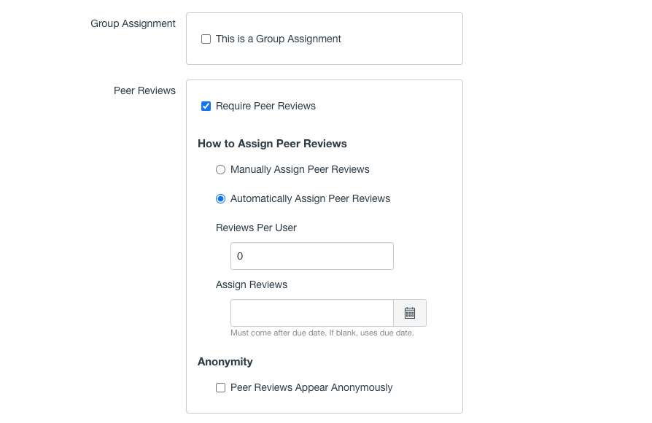
4. In order to maintain a level of objectivity and neutrality for students' responses, we encourage you to choose the anonymity function.
Resources
Boettcher, Judith V. and Rita Marie Conrad. 2016. The online teaching survival guide. 2nd Ed. San Francisco: Jossey-Bass.
Griffen, June. 2018. “Writing-Intensive Course.” High impact practices in online education. Ed. Kathryn E. Linder and Chrysanthemum Mattison Hayes. Sterling, VA: Stylus.
Li et al. 2010. “Assessor or assessee: how student learning improves by giving and receiving peer feedback.” British Journal of Educational Technology 41.3: 525-536.
Meeks, Melissa. 2017. “Teaching students to write better revision plans.” The Eli Review Blog. https://elireview.com/2017/05/22/teaching-revision-plans/.
Mulder et al. 2014. “Peer review in higher education: student perceptions before and after participation.” Active Learning in Higher Education 15.2: 157-171.
“Peer review strategies.” ProfessorPedia. https://inscribe.education/main/indianau/6754110229451715/compositions/6749461749435373?backToListTab=search&searchText=peer+review.
Wanner, Thomas and Edward Palmer. 2018. “Formative self-and peer assessment for improved student learning: the crucial factors of design, teacher participation and feedback.” Assessment & Evaluation in Higher Education 43.7: 1032-1047.

